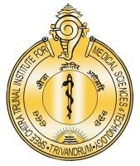

**श्री चित्रा तिरुनाल आयुर्विज्ञान और प्रौद्योगिकी संस्थान, त्रिवेंद्रम, तिरुवनन्तपुरम - 695 011, केरल, भारत**

SREE CHITRA TIRUNAL INSTITUTE FOR MEDICAL SCIENCES AND TECHNOLOGY (SCTIMST)

THIRUVANANTHAPURAM–695011, KERALA, INDIA

(An Institute of National Importance under DST; Government of India) (***एक राष्ट्रीय महत्व का संस्थान, विज्ञान एवं प्रौद्योगिकी विभाग, भारत सरकार)***

[www.sctimst.ac.in](http://www.sctimst.ac.in/)

Press Release

**26th Indo-US Flow Cytometry Workshop Inaugurated at Sree ChitraTirunal Institute for Medical Sciences and Technology**

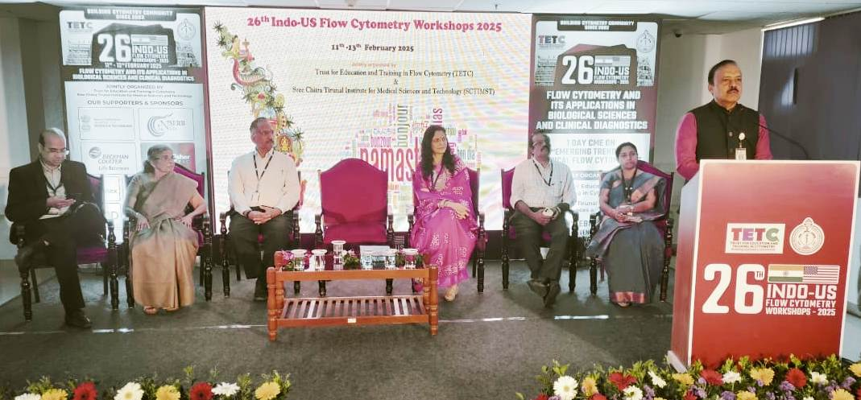

Thiruvananthapuram, February 11, 2025: The 26th Indo-US Flow Cytometry Workshop, jointly organized by Sree Chitra Tirunal Institute for Medical Sciences and Technology (SCTIMST) and the Trust for Education and Training in Cytometry (TETC), had been inaugurated. The three-day workshop, scheduled from February 11 to 13, 2025, focuses on Flow Cytometry and its Applications in Biological Sciences and Clinical Diagnostics. Additionally, a one-day Continuing Medical Education (CME) program has been organized to cater specifically to clinicians.

The workshop was inaugurated by Dr. S. Unnikrishnan Nair, Director, Vikram Sarabhai Space Centre (VSSC), in the esteemed presence of Dr. Sanjay Bihari, Director, SCTIMST, Dr. Harikrishna Varma, Head, Biomedical Technology Wing, SCTIMST, along with distinguished faculty members Dr. Anugya Bhatt, Dr. Rekha Gour, Dr. Lissy Krishnan, Dr. Hemant, and Dr. Amita R, among others. The event has drawn over 20 faculties and 120 participants from across the globe, reflecting the growing international interest in flow cytometry and its applications.

In his inaugural address, Dr. Sanjay Bihari, Director, SCTIMST emphasized the crucial role of flow cytometry in biomedical research and clinical diagnostics. He reaffirmed SCTIMST’s commitment to fostering innovation, advancing technology, and strengthening collaborative training programs to enhance medical research and patient care.

The Indo-US Flow Cytometry Workshop serves as a premier platform for hands-on training, expert-led discussions, and interactive sessions on the latest advancements in the field. Participants will explore cutting-edge cytometric techniques, data analysis strategies, and novel applications in both research and clinical settings.

This workshop provides an exceptional opportunity for researchers, academicians, and clinicians to engage with leading experts, expand their technical expertise, and apply advanced flow cytometry techniques to their respective fields. The knowledge and skills gained through this program are expected to contribute significantly to improved patient outcomes and scientific progress.